Aishwarya Mundley - 512038 PRN **:** 2019033800126543

**.NET Assignment - 6(b)**

Github link : <https://github.com/Aishwarya01-github/.NET-Assignments/tree/main/Lab%206>

1. **Code :**

**Code :**

using System;

using System.Collections;

using System.Collections.Specialized;

using System.Text;

namespace BitArraySample

{

class Program

{

static void BitArrayDemo()

{

var bits1 = new BitArray(8);

bits1.SetAll(true);

bits1.Set(1, false);

bits1[5] = false;

bits1[7] = false;

Console.Write("initialized: ");

DisplayBits(bits1);

Console.WriteLine();

DisplayBits(bits1);

bits1.Not();

Console.Write(" not ");

DisplayBits(bits1);

Console.WriteLine();

var bits2 = new BitArray(bits1);

bits2[0] = true;

bits2[1] = false;

bits2[4] = true;

DisplayBits(bits1);

Console.Write(" or ");

DisplayBits(bits2);

Console.Write(" : ");

bits1.Or(bits2);

DisplayBits(bits1);

Console.WriteLine();

DisplayBits(bits2);

Console.Write(" and ");

DisplayBits(bits1);

Console.Write(" : ");

bits2.And(bits1);

DisplayBits(bits2);

Console.WriteLine();

DisplayBits(bits1);

Console.Write(" xor ");

DisplayBits(bits2);

bits1.Xor(bits2);

Console.Write(" : ");

DisplayBits(bits1);

Console.WriteLine();

}

static void BitVectorDemo()

{

var bits1 = new BitVector32();

int bit1 = BitVector32.CreateMask();

int bit2 = BitVector32.CreateMask(bit1);

int bit3 = BitVector32.CreateMask(bit2);

int bit4 = BitVector32.CreateMask(bit3);

int bit5 = BitVector32.CreateMask(bit4);

bits1[bit1] = true;

bits1[bit2] = false;

bits1[bit3] = true;

bits1[bit4] = true;

Console.WriteLine(bits1);

bits1[0xabcdef] = true;

Console.WriteLine(bits1);

int received = 0x79abcdef;

var bits2 = new BitVector32(received);

Console.WriteLine(bits2);

// sections: FF EEE DDD CCCC BBBBBBBB AAAAAAAAAAAA

BitVector32.Section sectionA = BitVector32.CreateSection(0xfff);

BitVector32.Section sectionB = BitVector32.CreateSection(0xff, sectionA);

BitVector32.Section sectionC = BitVector32.CreateSection(0xf, sectionB);

BitVector32.Section sectionD = BitVector32.CreateSection(0x7, sectionC);

BitVector32.Section sectionE = BitVector32.CreateSection(0x7, sectionD);

BitVector32.Section sectionF = BitVector32.CreateSection(0x3, sectionE);

Console.WriteLine("Section A: " + IntToBinaryString(bits2[sectionA], true));

Console.WriteLine("Section B: " + IntToBinaryString(bits2[sectionB], true));

Console.WriteLine("Section C: " + IntToBinaryString(bits2[sectionC], true));

Console.WriteLine("Section D: " + IntToBinaryString(bits2[sectionD], true));

Console.WriteLine("Section E: " + IntToBinaryString(bits2[sectionE], true));

Console.WriteLine("Section F: " + IntToBinaryString(bits2[sectionF], true));

}

static string IntToBinaryString(int bits, bool removeTrailingZero)

{

var sb = new StringBuilder(32);

for (int i = 0; i < 32; i++)

{

if ((bits & 0x80000000) != 0)

{

sb.Append("1");

}

else

{

sb.Append("0");

}

bits = bits << 1;

}

string s = sb.ToString();

if (removeTrailingZero)

return s.TrimStart('0');

else

return s;

}

static void Main()

{

// BitArrayDemo();

BitVectorDemo();

}

static void DisplayBits(BitArray bits)

{

foreach (bool bit in bits)

{

Console.Write(bit ? 1 : 0);

}

}

}

}

**Output :**

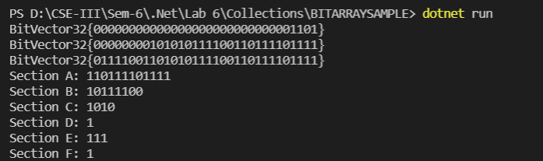

1. **ConCurrentSample :**

**Code :**

using System;

using System.Collections.Concurrent;

using System.Threading;

namespace ConcurrentSample

{

class Program

{

static void Main()

{

// BlockingDemo();

BlockingDemoSimple();

}

static void BlockingDemoSimple()

{

var sharedCollection = new BlockingCollection<int>();

var events = new ManualResetEventSlim[2];

var waits = new WaitHandle[2];

for (int i = 0; i < 2; i++)

{

events[i] = new ManualResetEventSlim(false);

waits[i] = events[i].WaitHandle;

}

var producer = new Thread(obj =>

{

var state = (Tuple<BlockingCollection<int>, ManualResetEventSlim>)obj;

var coll = state.Item1;

var ev = state.Item2;

var r = new Random();

for (int i = 0; i < 300; i++)

{

coll.Add(r.Next(3000));

}

ev.Set();

});

producer.Start(Tuple.Create<BlockingCollection<int>, ManualResetEventSlim>(sharedCollection, events[0]));

var consumer = new Thread(obj =>

{

var state = (Tuple<BlockingCollection<int>, ManualResetEventSlim>)obj;

var coll = state.Item1;

var ev = state.Item2;

for (int i = 0; i < 300; i++)

{

int result = coll.Take();

}

ev.Set();

});

consumer.Start(Tuple.Create<BlockingCollection<int>, ManualResetEventSlim>(sharedCollection, events[1]));

if (!WaitHandle.WaitAll(waits))

Console.WriteLine("wait failed");

else

Console.WriteLine("reading/writing finished");

}

static void BlockingDemo()

{

const int threadCount = 10;

ManualResetEventSlim[] events = new ManualResetEventSlim[threadCount];

WaitHandle[] waits = new WaitHandle[threadCount];

var consoleLock = new object();

for (int thread = 0; thread < threadCount; thread++)

{

events[thread] = new ManualResetEventSlim(false);

waits[thread] = events[thread].WaitHandle;

}

var sharedCollection = new BlockingCollection<int>();

for (int thread = 0; thread < threadCount >> 1; thread++)

{

var producer = new Thread((state) =>

{

var coll = ((Tuple<BlockingCollection<int>, ManualResetEventSlim>)state).Item1;

var wait = ((Tuple<BlockingCollection<int>, ManualResetEventSlim>)state).Item2;

var r = new Random();

for (int i = 0; i < 300; i++)

{

int data = r.Next(30000);

if (!coll.TryAdd(data))

{

Console.WriteLine("**** couldn't add");

}

else

{

lock (consoleLock)

{

Console.ForegroundColor = ConsoleColor.Cyan;

Console.Write(" {0} ", data);

Console.ResetColor();

}

}

Thread.Sleep(r.Next(40));

}

wait.Set();

});

producer.Start(Tuple.Create<BlockingCollection<int>, ManualResetEventSlim>(sharedCollection, events[thread]));

}

Thread.Sleep(500); // give the producers a headstart

for (int thread = threadCount >> 1; thread < threadCount; thread++)

{

var consumer = new Thread((state) =>

{

var coll = ((Tuple<BlockingCollection<int>, ManualResetEventSlim>)state).Item1;

var wait = ((Tuple<BlockingCollection<int>, ManualResetEventSlim>)state).Item2;

var r = new Random();

for (int i = 0; i < 3000; i++)

{

int result;

if (!coll.TryTake(out result))

{

Console.WriteLine("couldn't take");

}

else

{

lock (consoleLock)

{

Console.ForegroundColor = ConsoleColor.Red;

Console.WriteLine(" {0} ", result);

Console.ResetColor();

}

}

Thread.Sleep(r.Next(40));

}

wait.Set();

});

consumer.Start(Tuple.Create<BlockingCollection<int>, ManualResetEventSlim>(sharedCollection, events[thread]));

}

if (!WaitHandle.WaitAll(waits))

Console.WriteLine("error waiting...");

}

}

}

**Output :**

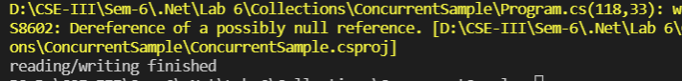

1. **DictionarySample :**

**Code :**

using System;

using System.Collections.Generic;

namespace Wrox.ProCSharp.Collections

{

class Program

{

static void Main()

{

var employees = new Dictionary<EmployeeId, Employee>(31);

var idKyle = new EmployeeId("T3755");

var kyle = new Employee(idKyle, "Kyle Bush", 5443890.00m);

employees.Add(idKyle, kyle);

Console.WriteLine(kyle);

var idCarl = new EmployeeId("F3547");

var carl = new Employee(idCarl, "Carl Edwards", 5597120.00m);

employees.Add(idCarl, carl);

Console.WriteLine(carl);

var idJimmie = new EmployeeId("C3386");

var jimmie = new Employee(idJimmie, "Jimmie Johnson", 5024710.00m);

employees.Add(idJimmie, jimmie);

Console.WriteLine(jimmie);

var idDale = new EmployeeId("C3323");

var dale = new Employee(idDale, "Dale Earnhardt Jr.", 3522740.00m);

employees[idDale] = dale;

Console.WriteLine(dale);

var idJeff = new EmployeeId("C3234");

var jeff = new Employee(idJeff, "Jeff Burton", 3879540.00m);

employees[idJeff] = jeff;

Console.WriteLine(jeff);

while (true)

{

Console.Write("Enter employee id (X to exit)> ");

var userInput = Console.ReadLine();

userInput = userInput.ToUpper();

if (userInput == "X") break;

EmployeeId id;

try

{

id = new EmployeeId(userInput);

Employee employee;

if (!employees.TryGetValue(id, out employee))

{

Console.WriteLine("Employee with id {0} does not exist", id);

}

else

{

Console.WriteLine(employee);

}

}

catch (EmployeeIdException ex)

{

Console.WriteLine(ex.Message);

}

}

}

}

}

**Employee.cs**

using System;

namespace Wrox.ProCSharp.Collections

{

[Serializable]

public class Employee

{

private string name;

private decimal salary;

private readonly EmployeeId id;

public Employee(EmployeeId id, string name, decimal salary)

{

this.id = id;

this.name = name;

this.salary = salary;

}

public override string ToString()

{

return String.Format("{0}: {1, -20} {2:C}",

id.ToString(), name, salary);

}

}

}

**EmployeeId.cs**

using System;

namespace Wrox.ProCSharp.Collections

{

[Serializable]

public class EmployeeIdException : Exception

{

public EmployeeIdException(string message) : base(message) { }

}

[Serializable]

public struct EmployeeId : IEquatable<EmployeeId>

{

private readonly char prefix;

private readonly int number;

public EmployeeId(string id)

{

if (id == null) throw new ArgumentNullException("id");

prefix = (id.ToUpper())[0];

int numLength = id.Length - 1;

try

{

number = int.Parse(id.Substring(1, numLength > 6 ? 6 : numLength));

}

catch (FormatException)

{

throw new EmployeeIdException("Invalid EmployeeId format");

}

}

public override string ToString()

{

return prefix.ToString() + string.Format("{0,6:000000}", number);

}

public override int GetHashCode()

{

return (number ^ number << 16) * 0x15051505;

}

public bool Equals(EmployeeId other)

{

if (other == null) return false;

return (prefix == other.prefix && number == other.number);

}

public override bool Equals(object obj)

{

return Equals((EmployeeId)obj);

}

public static bool operator ==(EmployeeId left, EmployeeId right)

{

return left.Equals(right);

}

public static bool operator !=(EmployeeId left, EmployeeId right)

{

return !(left == right);

}

}

}

**Output :**

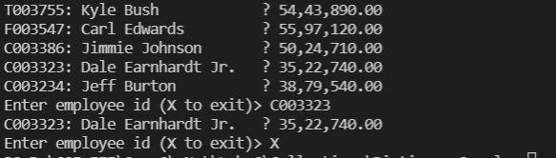

1. **LinkedListSample:**

**Code :**

namespace Wrox.ProCSharp.Collections

{

class Program

{

static void Main()

{

PriorityDocumentManager pdm = new PriorityDocumentManager();

pdm.AddDocument(new Document("one", "Sample", 8));

pdm.AddDocument(new Document("two", "Sample", 3));

pdm.AddDocument(new Document("three", "Sample", 4));

pdm.AddDocument(new Document("four", "Sample", 8));

pdm.AddDocument(new Document("five", "Sample", 1));

pdm.AddDocument(new Document("six", "Sample", 9));

pdm.AddDocument(new Document("seven", "Sample", 1));

pdm.AddDocument(new Document("eight", "Sample", 1));

pdm.DisplayAllNodes();

}

}

}

**Document.cs**

namespace Wrox.ProCSharp.Collections

{

public class Document

{

public string Title { get; private set; }

public string Content { get; private set; }

public byte Priority { get; private set; }

public Document(string title, string content, byte priority = 0)

{

this.Title = title;

this.Content = content;

this.Priority = priority;

}

}

}

**PriorityDocumentManager.cs**

using System;

using System.Collections.Generic;

namespace Wrox.ProCSharp.Collections

{

public class PriorityDocumentManager

{

private readonly LinkedList<Document> documentList;

// priorities 0.9

private readonly List<LinkedListNode<Document>> priorityNodes;

public PriorityDocumentManager()

{

documentList = new LinkedList<Document>();

priorityNodes = new List<LinkedListNode<Document>>(10);

for (int i = 0; i < 10; i++)

{

priorityNodes.Add(new LinkedListNode<Document>(null));

}

}

public void AddDocument(Document d)

{

if (d == null) throw new ArgumentNullException("d");

AddDocumentToPriorityNode(d, d.Priority);

}

private void AddDocumentToPriorityNode(Document doc, int priority)

{

if (priority > 9 || priority < 0)

throw new ArgumentException("Priority must be between 0 and 9");

if (priorityNodes[priority].Value == null)

{

--priority;

if (priority >= 0)

{

// check for the next lower priority

AddDocumentToPriorityNode(doc, priority);

}

else // now no priority node exists with the same priority or lower

// add the new document to the end

{

documentList.AddLast(doc);

priorityNodes[doc.Priority] = documentList.Last;

}

return;

}

else // a priority node exists

{

LinkedListNode<Document> prioNode = priorityNodes[priority];

if (priority == doc.Priority)

// priority node with the same priority exists

{

documentList.AddAfter(prioNode, doc);

// set the priority node to the last document with the same priority

priorityNodes[doc.Priority] = prioNode.Next;

}

else // only priority node with a lower priority exists

{

// get the first node of the lower priority

LinkedListNode<Document> firstPrioNode = prioNode;

while (firstPrioNode.Previous != null &&

firstPrioNode.Previous.Value.Priority == prioNode.Value.Priority)

{

firstPrioNode = prioNode.Previous;

prioNode = firstPrioNode;

}

documentList.AddBefore(firstPrioNode, doc);

// set the priority node to the new value

priorityNodes[doc.Priority] = firstPrioNode.Previous;

}

}

}

public void DisplayAllNodes()

{

foreach (Document doc in documentList)

{

Console.WriteLine("priority: {0}, title {1}", doc.Priority, doc.Title);

}

}

// returns the document with the highest priority

// (that's first in the linked list)

public Document GetDocument()

{

Document doc = documentList.First.Value;

documentList.RemoveFirst();

return doc;

}

}

}

**Output :**

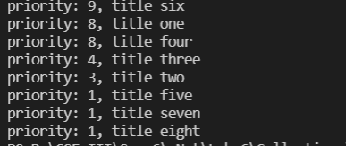

**5) ListSample :**

**Code :**

using System.Collections.Generic;

namespace Wrox.ProCSharp.Collections

{

class Program

{

static void Main()

{

var graham = new Racer(7, "Graham", "Hill", "UK", 14);

var emerson = new Racer(13, "Emerson", "Fittipaldi", "Brazil", 14);

var mario = new Racer(16, "Mario", "Andretti", "USA", 12);

var racers = new List<Racer>(20) { graham, emerson, mario };

racers.Add(new Racer(24, "Michael", "Schumacher", "Germany", 91));

racers.Add(new Racer(27, "Mika", "Hakkinen", "Finland", 20));

racers.AddRange(new Racer[] {

new Racer(14, "Niki", "Lauda", "Austria", 25),

new Racer(21, "Alain", "Prost", "France", 51)});

var racers2 = new List<Racer>(new Racer[] {

new Racer(12, "Jochen", "Rindt", "Austria", 6),

new Racer(22, "Ayrton", "Senna", "Brazil", 41) });

}

}

}

**Racer.cs**

using System;

namespace Wrox.ProCSharp.Collections

{

[Serializable]

public class Racer : IComparable<Racer>, IFormattable

{

public int Id { get; private set; }

public string FirstName { get; set; }

public string LastName { get; set; }

public string Country { get; set; }

public int Wins { get; set; }

public Racer(int id, string firstName, string lastName, string country = null, int wins = 0)

{

this.Id = id;

this.FirstName = firstName;

this.LastName = lastName;

this.Country = country;

this.Wins = wins;

}

public override string ToString()

{

return String.Format("{0} {1}", FirstName, LastName);

}

public string ToString(string format, IFormatProvider formatProvider)

{

switch (format.ToUpper())

{

case null:

case "N": // name

return ToString();

case "F": // first name

return FirstName;

case "L": // last name

return LastName;

case "W": // Wins

return String.Format("{0}, Wins: {1}", ToString(), Wins);

case "C": // Country

return String.Format("{0}, Country: {1}", ToString(), Country);

case "A": // All

return String.Format("{0}, {1} Wins: {2}", ToString(), Country, Wins);

default:

throw new FormatException(String.Format(formatProvider,

"Format {0} is not supported", format));

}

}

public string ToString(string format)

{

return ToString(format, null);

}

public int CompareTo(Racer other)

{

int compare = this.LastName.CompareTo(other.LastName);

if (compare == 0)

return this.FirstName.CompareTo(other.FirstName);

return compare;

}

}

}

**RacerComparer.cs**

using System;

using System.Collections.Generic;

namespace Wrox.ProCSharp.Collections

{

public enum CompareType

{

FirstName,

LastName,

Country,

Wins

}

public class RacerComparer : IComparer<Racer>

{

private CompareType compareType;

public RacerComparer(CompareType compareType)

{

this.compareType = compareType;

}

public int Compare(Racer x, Racer y)

{

if (x == null) throw new ArgumentNullException("x");

if (y == null) throw new ArgumentNullException("y");

int result;

switch (compareType)

{

case CompareType.FirstName:

return x.FirstName.CompareTo(y.FirstName);

case CompareType.LastName:

return x.LastName.CompareTo(y.LastName);

case CompareType.Country:

if ((result = x.Country.CompareTo(y.Country)) == 0)

return x.LastName.CompareTo(y.LastName);

else

return result;

case CompareType.Wins:

return x.Wins.CompareTo(y.Wins);

default:

throw new ArgumentException("Invalid Compare Type");

}

}

}

}

**6) LookUpSample :**

**Code :**

using System;

using System.Collections.Generic;

using System.Linq;

namespace Wrox.ProCSharp.Collections

{

class Program

{

static void Main()

{

var racers = new List<Racer>();

racers.Add(new Racer(26, "Jacques", "Villeneuve", "Canada", 11));

racers.Add(new Racer(18, "Alan", "Jones", "Australia", 12));

racers.Add(new Racer(11, "Jackie", "Stewart", "United Kingdom", 27));

racers.Add(new Racer(15, "James", "Hunt", "United Kingdom", 10));

racers.Add(new Racer(5, "Jack", "Brabham", "Australia", 14));

var lookupRacers = racers.ToLookup(r => r.Country);

foreach (Racer r in lookupRacers["Australia"])

{

Console.WriteLine(r);

}

}

}

}

**Racer.cs**

using System;

namespace Wrox.ProCSharp.Collections

{

[Serializable]

public class Racer : IComparable<Racer>, IFormattable

{

public int Id { get; private set; }

public string FirstName { get; set; }

public string LastName { get; set; }

public string Country { get; set; }

public int Wins { get; set; }

public Racer(int id, string firstName, string lastName, string country = null, int wins = 0)

{

this.Id = id;

this.FirstName = firstName;

this.LastName = lastName;

this.Country = country;

this.Wins = wins;

}

public override string ToString()

{

return String.Format("{0} {1}", FirstName, LastName);

}

public string ToString(string format, IFormatProvider formatProvider)

{

if (format == null) format = "N";

switch (format.ToUpper())

{

case "N": // name

return ToString();

case "F": // first name

return FirstName;

case "L": // last name

return LastName;

case "W": // Wins

return String.Format("{0}, Wins: {1}", ToString(), Wins);

case "C": // Country

return String.Format("{0}, Country: {1}", ToString(), Country);

case "A": // All

return String.Format("{0}, {1} Wins: {2}", ToString(), Country, Wins);

default:

throw new FormatException(String.Format(formatProvider,

"Format {0} is not supported", format));

}

}

public string ToString(string format)

{

return ToString(format, null);

}

public int CompareTo(Racer other)

{

int compare = this.LastName.CompareTo(other.LastName);

if (compare == 0)

return this.FirstName.CompareTo(other.FirstName);

return compare;

}

}

}

**Output :**



**7) ObservableCollectionSample**

**Code :**

using System;

using System.Collections.ObjectModel;

namespace Wrox.ProCSharp.Collections

{

class Program

{

static void Main()

{

var data = new ObservableCollection<string>();

data.CollectionChanged += Data_CollectionChanged;

data.Add("One");

data.Add("Two");

data.Insert(1, "Three");

data.Remove("One");

}

static void Data_CollectionChanged(object sender, System.Collections.Specialized.NotifyCollectionChangedEventArgs e)

{

Console.WriteLine("action: {0}", e.Action.ToString());

if (e.OldItems != null)

{

Console.WriteLine("starting index for old item(s): {0}", e.OldStartingIndex);

Console.WriteLine("old item(s):");

foreach (var item in e.OldItems)

{

Console.WriteLine(item);

}

}

if (e.NewItems != null)

{

Console.WriteLine("starting index for new item(s): {0}", e.NewStartingIndex);

Console.WriteLine("new item(s): ");

foreach (var item in e.NewItems)

{

Console.WriteLine(item);

}

}

Console.WriteLine();

}

}

}

**Output :**

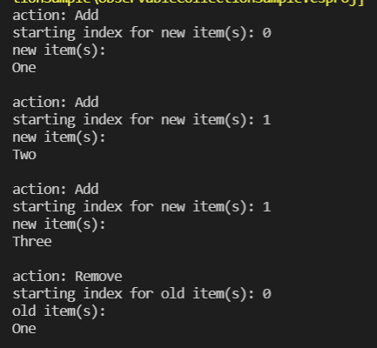

**8) QueueSample :**

**Code :**

using System;

using System.Threading;

namespace Wrox.ProCSharp.Collections

{

class Program

{

static void Main()

{

var dm = new DocumentManager();

ProcessDocuments.Start(dm);

// Create documents and add them to the DocumentManager

for (int i = 0; i < 1000; i++)

{

Document doc = new Document("Doc " + i.ToString(), "content");

dm.AddDocument(doc);

Console.WriteLine("Added document {0}", doc.Title);

Thread.Sleep(new Random().Next(20));

}

}

}

}

**Document.cs**

using System;

using System.Collections.Generic;

using System.Linq;

using System.Text;

namespace Wrox.ProCSharp.Collections

{

public class Document

{

public string Title { get; private set; }

public string Content { get; private set; }

public Document(string title, string content)

{

this.Title = title;

this.Content = content;

}

}

}

**DocumentManager.cs**

using System.Collections.Generic;

namespace Wrox.ProCSharp.Collections

{

public class DocumentManager

{

private readonly Queue<Document> documentQueue = new Queue<Document>();

public void AddDocument(Document doc)

{

lock (this)

{

documentQueue.Enqueue(doc);

}

}

public Document GetDocument()

{

Document doc = null;

lock (this)

{

doc = documentQueue.Dequeue();

}

return doc;

}

public bool IsDocumentAvailable

{

get

{

return documentQueue.Count > 0;

}

}

}

}

**ProcessDoucments.cs**

using System;

using System.Threading;

namespace Wrox.ProCSharp.Collections

{

public class ProcessDocuments

{

public static void Start(DocumentManager dm)

{

new Thread(new ProcessDocuments(dm).Run).Start();

}

protected ProcessDocuments(DocumentManager dm)

{

documentManager = dm;

}

private DocumentManager documentManager;

protected void Run()

{

while (true)

{

if (documentManager.IsDocumentAvailable)

{

Document doc = documentManager.GetDocument();

Console.WriteLine("Processing document {0}", doc.Title);

}

Thread.Sleep(new Random().Next(20));

}

}

}

}

**Output :**

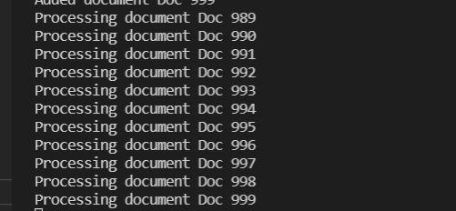

**9) SetSample :**

**Code :**

using System;

using System.Collections.Generic;

namespace SetSample

{

class Program

{

static void Main()

{

var companyTeams = new HashSet<string>() { "Ferrari", "McLaren", "Toyota", "BMW", "Renault" };

var traditionalTeams = new HashSet<string>() { "Ferrari", "McLaren" };

var privateTeams = new HashSet<string>() { "Red Bull", "Toro Rosso", "Force India", "Brawn GP" };

if (privateTeams.Add("Williams"))

Console.WriteLine("Williams added");

if (!companyTeams.Add("McLaren"))

Console.WriteLine("McLaren was already in this set");

if (traditionalTeams.IsSubsetOf(companyTeams))

{

Console.WriteLine("traditionalTeams is subset of companyTeams");

}

if (companyTeams.IsSupersetOf(traditionalTeams))

{

Console.WriteLine("companyTeams is a superset of traditionalTeams");

}

traditionalTeams.Add("Williams");

if (privateTeams.Overlaps(traditionalTeams))

{

Console.WriteLine("At least one team is the same with the traditional " +

"and private teams");

}

var allTeams = new SortedSet<string>(companyTeams);

allTeams.UnionWith(privateTeams);

allTeams.UnionWith(traditionalTeams);

Console.WriteLine();

Console.WriteLine("all teams");

foreach (var team in allTeams)

{

Console.WriteLine(team);

}

allTeams.ExceptWith(privateTeams);

Console.WriteLine();

Console.WriteLine("no private team left");

foreach (var team in allTeams)

{

Console.WriteLine(team);

}

}

}

}

**Output :**

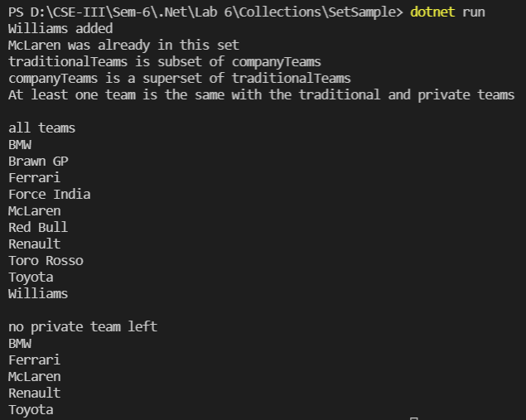

**10) SortedListSample**

**Code :**

using System;

using System.Collections.Generic;

using System.Linq;

using System.Text;

namespace Wrox.ProCSharp.Collections

{

class Program

{

static void Main(string[] args)

{

var books = new SortedList<string, string>();

books.Add("C# 2008 Wrox Box", "978–0–470–047205–7");

books.Add("Professional ASP.NET MVC 1.0", "978–0–470–38461–9");

books["Beginning Visual C# 2008"] = "978–0–470-19135-4";

books["Professional C# 2008"] = "978–0–470–19137–6";

foreach (KeyValuePair<string, string> book in books)

{

Console.WriteLine("{0}, {1}", book.Key, book.Value);

}

foreach (string isbn in books.Values)

{

Console.WriteLine(isbn);

}

foreach (string title in books.Keys)

{

Console.WriteLine(title);

}

{

string isbn;

string title = "Professional C# 7.0";

if (!books.TryGetValue(title, out isbn))

{

Console.WriteLine("{0} not found", title);

}

}

}

}

}

**Output :**

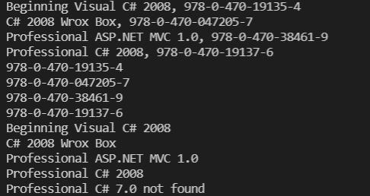

**11) StackSample**

**Code :**

using System;

using System.Collections.Generic;

namespace Wrox.ProCSharp.Collections

{

class Program

{

static void Main()

{

var alphabet = new Stack<char>();

alphabet.Push('A');

alphabet.Push('B');

alphabet.Push('C');

Console.Write("First iteration: ");

foreach (char item in alphabet)

{

Console.Write(item);

}

Console.WriteLine();

Console.Write("Second iteration: ");

while (alphabet.Count > 0)

{

Console.Write(alphabet.Pop());

}

Console.WriteLine();

}

}

}

**Output :**